NTU-Deye 合作实验室备忘录

1. 引言

在向可持续能源过渡的进程中，Deye（德业公司，作为光伏逆变器和储能解决方案的领先提供商）希望强化其现有的基于人工智能的电力系统，并引入绿色能源资产去中心化框架。这一自上而下的愿景源于Deye的实际需求：利用人工智能优化能源管理，同时运用区块链技术实现绿色能源资产的去中心化和通证化。通过将人工智能驱动的能源管理系统与基于区块链的实物资产 (RWA) 平台相结合，德业力求最大化可再生能源的利用率，提高产消者的收益，并让更广泛的群体参与清洁能源市场。

为实现这一目标，我们首先概述德业人工智能系统（即Deye Copilot）的现状，其次描述去中心化绿色能源资产系统（RWA系统）的整体结构，最后梳理两个领域中存在的主要挑战，并据此提出针对性的研究方向（工作计划，Work Packages）。这种结构化方案从宏观需求出发，逐层细化至具体的研究问题，提供了一条从高层愿景到实施细节的清晰路径。

1.1. Deye Copilot 的现状：进展与挑战
德业开发了智能能源管理系统“Copilot”（副驾），充当其逆变器的AI“副驾驶”。该系统最初在澳大利亚推出，如今已部署于多个全球市场，它将基于人工智能的核心算法（“能源管家”Energy Saver）与云端虚拟电厂(VPP)网络融合在一个平台上[1]。Copilot能够根据实时电价、天气预报、负载需求预测、电池健康状态等数据动态优化电池充放电策略 [2]。 Copilot能够根据实时电价、天气预报、负载需求预测、电池健康状态等数据动态优化电池充放电策略 [2]。实践证明，Copilot带来了可观效益：例如，某用户的光储系统（23 kW光伏+40 kWh电池）在启用Copilot后，月均收益增加约80澳元，系统投资回收期由约7.6年缩短至5.6年 [2]。 本质上，Copilot建立了“基础收益+增值收益”两层收入模型：除电价套利获得的基础收益外，用户通过参与更多电网服务获取附加价值。
在云端平台方面，Deye Copilot已对接多个虚拟电厂运营商（如Evergen、Greensync、Termina、Amber等），将分布式能源资源聚合参与电力市场服务。借助这一“VPP网络”，用户能够将富余能源投向辅助服务市场（如频率调节）或绿色证书交易，进一步货币化闲置的清洁能源。这体现了储能商业模式从传统单一市场利用向多层次价值叠加的转变。Copilot实质上充当智能调度枢纽，在满足本地用能的同时，将剩余电能通过开放的接口输送至外部市场——Deye将这一机制形象地称为“VPP超市”，用户可灵活选择如何处置自己的能源资产。
尽管取得了上述进展，Copilot要完全发挥潜力仍面临若干问题与挑战，需要进一步解决：
- 首先是算法性能与一致性方面仍有改进空间。一些早期用户反馈，AI决策有时并不理想；在某些情况下，Copilot的充放电策略选择不当，反而增加了用电成本，未能达到预期的省电效果 [3]。这表明优化算法需要进一步调优，并在更广泛的真实场景中严格验证，以确保应对各种工况（例如，非常规的电价波动或负载模式）时也能保持最佳表现。
- 第二，用户控制和系统干预也是一大挑战。AI有时会自动调整逆变器设置，超出用户预期，导致少数用户因不放心其自主操作而切换回手动模式。据社区论坛反映，Copilot在启用后会自动修改某些参数，令用户困惑，这在一定程度上削弱了用户对全自动模式的信任。因此，如何提高系统运行的透明度和可控性（例如通过更友好的用户界面、允许用户设定偏好或安全限制）对于用户接受度至关重要。
- 第三，数据范围和预测模型可进一步扩展。目前Copilot整合了电价、天气等关键因素，但将来可以纳入更细粒度的数据（如住户用电习惯、电动汽车充电计划、区域电网信号等）并提升预测精度（借助更先进的AI模型），以增强系统智能决策的“基本功”。
- 最后，随着Copilot走向更多国家市场，还会出现可扩展性和适应性问题。各地电力市场规则、费率结构、VPP项目不尽相同，需要AI和云平台能因地制宜地调整（同时保持性能稳定），这是一项不小的挑战。
综上所述，当前阶段的Deye Copilot奠定了良好基础——证明了AI驱动的能源优化结合多层次收益的可行性，但也清晰暴露出需强化AI核心算法、可靠性和适应性的需求。这些需求促使我们针对下一代能源管理AI技术开展深入研究。

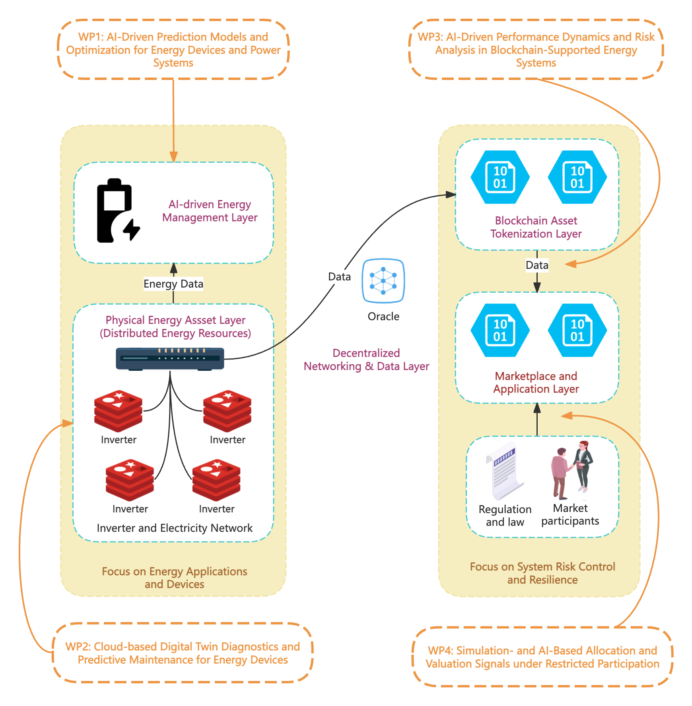
Deye Copilot’s cloud platform also integrates with multiple VPP operators (e.g. Evergen, Greensync, Termina, Amber) to aggregate distributed energy resources for grid services. Through this “VPP network”, a user can opt into ancillary service markets like frequency regulation or green certificate trading, further monetizing surplus energy. This reflects a shift from traditional single-market use to multi-layered value stacking in energy storage. The Copilot system effectively acts as a smart dispatcher that can route energy either for local use or into external markets, creating what Deye calls a “VPP supermarket” where users flexibly choose how to deploy their assets.
Despite this progress, several issues and challenges have been identified that need to be resolved to fully realize Copilot’s potential.
- First, algorithmic performance and consistency remain areas for improvement. Early adopters reported that the AI’s decisions were not always optimal; in some cases the Copilot made poor charging/discharging choices that increased costs or didn’t minimize grid purchases as expected [3]. Such feedback indicates that the AI optimization algorithms may need further tuning and robust validation to handle diverse real-world scenarios (e.g. unusual tariff patterns or load behaviors).
- Second, user control and system overrides present a challenge. The AI sometimes adjusts inverter settings in ways the user did not anticipate, leading a few users to revert to manual settings. For instance, community forum reports noted that Copilot automatically altered certain inverter parameters, which confused users and eroded trust in autonomous mode. Ensuring a transparent and user-aligned operation (perhaps through better UI, user-configurable goals, or fail-safes) is therefore important for user acceptance.
- Third, the scope of data and predictive models can be expanded. Copilot currently integrates key variables (price, weather, etc.), but incorporating more granular data (like household consumption patterns, EV charging schedules, or regional grid signals) and improving forecasting accuracy (through advanced AI models) will be crucial to enhance the system’s fundamental AI capabilities.
- Forth, scalability and interoperability issues may arise as the Copilot is rolled out to more markets worldwide. Each electricity market has unique regulations, tariff structures, and VPP programs; adapting the AI and cloud platform to these local conditions (while maintaining performance) is a non-trivial challenge.
In summary, the current stage of Deye Copilot is a promising foundation – it validates the concept of AI-driven energy optimization with multi-layer revenue streams – but there is a clear need to strengthen the AI’s fundamental algorithms, reliability, and adaptability to fully meet Deye’s goals. These needs motivate targeted research into next-generation AI energy management techniques.

1.2. Decentralized Green Energy Asset System: Overall Structure
In parallel with improving the AI-based EMS, Deye envisions a decentralized green energy asset system that tokenizes and manages renewable energy assets on a blockchain – essentially an implementation of Real-World Asset (RWA) tokenization for green energy. The overall structure of this system spans multiple layers bridging physical infrastructure and digital finance:
- Physical Energy Asset Layer (Distributed Energy Resources): At the base are the physical green energy assets – solar PV panels, home batteries, electric vehicles, wind turbines, etc. – owned by prosumers or communities. These are often equipped with IoT sensors, smart meters, and controllers (e.g. Deye inverters with Copilot EMS) that digitize their operations. The high degree of digitization (e.g. in battery management systems and inverter controls) provides real-time data on generation, storage, and consumption [4].
- AI-Driven Energy Management Layer: This layer comprises intelligent controllers and algorithms (like Deye Copilot’s AI or an “EnergyGPT” agent) that serve as the “brain” for distributed assets. They forecast supply and demand, optimize dispatch, and ensure efficient use of each asset. The AI can perform tasks such as load forecasting, dynamic pricing arbitrage, battery health management, and even predictive maintenance. In a decentralized context, each device or site may run an automated agent that interacts with the network – making local decisions for the asset owner’s benefit while responding to external signals (prices, grid needs). This AI layer maximizes cost savings and energy efficiency on the ground, providing the fundamental energy management capabilities required before any trading or tokenization occurs.
- Decentralized Networking & Data Layer (DePIN Infrastructure): To connect many distributed assets securely and reliably, a Decentralized Physical Infrastructure Network (DePIN) is employed. DePIN refers to leveraging blockchain and IoT to create a trusted network of devices. In this context, each energy device (or a gateway aggregating a local site) is a node in a decentralized network. This network handles device authentication, data logging, and communications using distributed ledger technology, ensuring that data (e.g. energy produced/consumed) is verifiable and tamper-resistant. Essentially, the DePIN layer is the “heart and veins” of the system – it pumps data from millions of edge devices into the digital ecosystem and enforces secure connectivity. This could be achieved via IoT blockchain protocols or oracles that feed real-world energy data onto the blockchain in near-real-time.
- Blockchain Asset Tokenization Layer: On top of the infrastructure, the RWA tokenization layer turns energy assets and their outputs into digital tokens on a blockchain. Each token can represent a specific asset. Smart contracts define how tokens are issued, transferred, and redeemed. For instance, when a prosumer produces surplus solar energy, a smart contract could automatically issue them a green energy credit token, which could then be sold or traded. Conversely, investors could purchase tokens that represent a stake in a renewable installation’s future output. This tokenization makes traditionally illiquid energy assets more liquid and tradable, lowering the barrier for participation. Small investors can buy fractions of a renewable energy project, and individuals can directly trade energy tokens peer-to-peer.
- Marketplace and Application Layer: At the top, user-facing platforms and markets allow stakeholders to interact with the tokenized energy assets. This includes decentralized exchanges or trading platforms where energy tokens are bought and sold (or automated market makers enabling continuous liquidity for energy credits). It also includes investment platforms or crowdfunding portals where investors purchase tokens to fund new green installations. Peer-to-peer trading interfaces might let consumers buy locally generated green energy tokens directly from producers, bypassing traditional utilities. Additionally, secondary services like green certificate trading (for renewable energy credits) can be integrated, as well as governance mechanisms for community energy projects (token holders voting on project decisions, etc.). The marketplace layer would handle diverse participants – prosumers, consumers, aggregators, investors, even traditional utilities – each using tokens according to their needs (for example, a company buying tokens to offset its carbon footprint with renewable credits). Crucially, this layer must interface with existing energy systems (markets and grids) to be meaningful; for example, tokens might be redeemable for actual energy supply or for fiat via regulated entities.

[1] R. Sengupta, “Deye Launches AI-powered ‘Deye Copilot’ For Australia,” TaiyangNews - All About Solar Power. Accessed: Jan. 28, 2026. [Online]. Available: https://taiyangnews.info/technology/deye-technologies-copilot-ai-virtual-assistant-australia
[2] pv magazine, “‘Deye Copilot’: AI-Driven ‘Energy Saver’ Builds a Multi-Layered Revenue Model for Energy Storage,” pv magazine International. Accessed: Jan. 28, 2026. [Online]. Available: https://www.pv-magazine.com/press-releases/deye-copilot-ai-driven-energy-saver-builds-a-multi-layered-revenue-model-for-energy-storage/
[3] “Deye copilot,” Power Forum - Renewable Energy Discussion. Accessed: Jan. 29, 2026. [Online]. Available: https://powerforum.co.za/topic/32057-deye-copilot/
[4] “Why ‘Green Energy + DePIN + AI’ is the Optimal Asset for RWA?” Accessed: Jan. 29, 2026. [Online]. Available: https://www.gate.com/learn/articles/why-green-energy-depin-ai-is-the-optimal-asset-for-rwa/3824

